7

Some useful information:

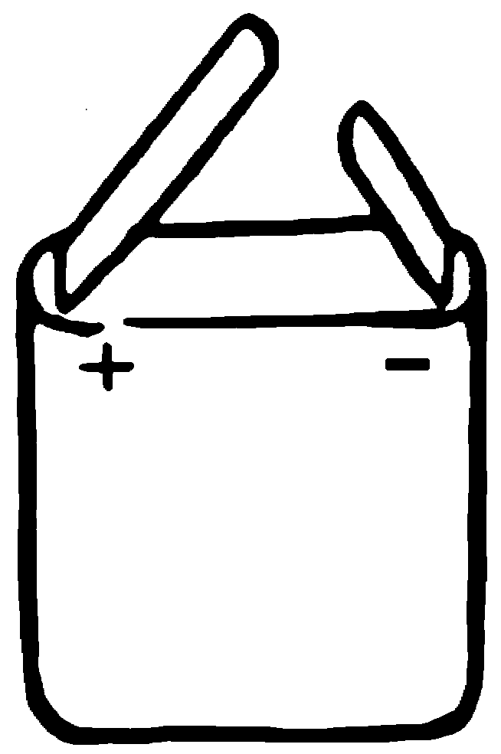  The two contact points on this battery are the two metal strips: |  | The two contact points on this bulb are at the ends:

Look at each of the circuits below. Tick one box () to show if the bulb is lit or not.

a. b. c.

.

not lit
lit
.

not lit
lit
.

not lit
lit

d. e. f.

.

not lit
lit
.

not lit
lit
.

not lit
lit

